To increase the performance of composition filters we can perform filter inlining. Filter inlining is transforming the filterset to semantically equivalent target language code and weaving this code in the correct places in the base program.
This document describes how a filterset can be transformed to code and how this code can be weaved into the base program. It starts with explaining three new filtertypes that have been added to Compose* to replace the Meta filtertype. In the next chapter is explained how FIRE’s ExecutionModel can be used to generate the inlining code structure. The third chapter explains the Abstract Instruction Model, a platform independent model to represent the code structure generated from the ExecutionModel. The fourth chapter explains strategies for implementing the FilterActions, which were until now treated as abstract actions. Finally the actual weaving of the code is explained.

Before, After and Skip filter semantics
Three new filtertypes are introduced to replace Meta filters. These are Before, After and Skip. This section explains the semantics of these filtertypes.

Before filter
A Before action is executed when the Before filter accepts. It does a call to a method, specified in the substitutionpart, which implements the Before advice. The method is given as an argument a JoinPointContext object, containing the message (selector and target), the sender (when available) and the types and values of the arguments. The Before filter might change the values of the arguments. It is not allowed to change the message, because this leads to a hidden change in the flow through the filterset, which makes reasoning about the flow through the filterset more difficult.

After filter
The after filter is not executed in the normal filter flow but postponed until a dispatch or skip action has been executed. This behaviour is different from the normal flow through the filterset. The following picture shows how flow would normally go through a filterset:
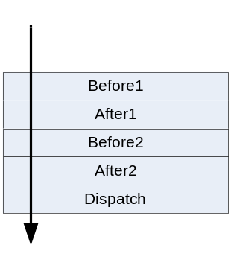
With the normal flow the filters are executed when they are encountered. In this way the After filters After1 and After2 are executed before the Dispatch. But we want the After actions to be executed after the Dispatch action. In Meta filters this was implemented by doing a proceed in the advice code, which proceeded the execution of the filterset and returned to the advice code after the filterset had ended the execution. But this is not entirely what we want, because in this way the filtercode that leads to the After action, for example the checking of the condition expressions, is executed before the Dispatch. But the Dispatch might change conditions and so might change the behaviour of the After filters. Therefore we want the complete After filter to be executed after the Dispatch, not only the After advice. This is shown in the following picture, where the execution of a filter is indicated with a dot:

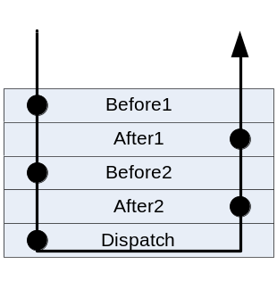

In this picture it is shown that on the forward pass through the filterset the After filters are ignored. When a Dispatch filter leading to a Dispatch action is reached, the flow doesn’t end, but returns backward through the filterset executing the After filters.

Because flow returns backward through the filterset after a Dispatch, After filters are only executed when they are defined before the Dispatch filter. After (and Before) filters defined after a Dispatch filter are not executed if the Dispatch filter does a Dispatch action, as shown in the following picture:
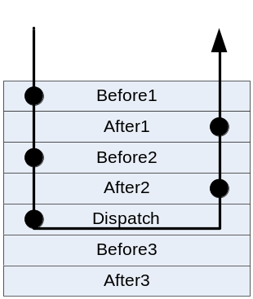

Skip filter
With a Skip filter the forward flow through a filterset can be aborted and be returned backward through the filterset. In this way we can avoid a Dispatch. This is shown in the following picture.
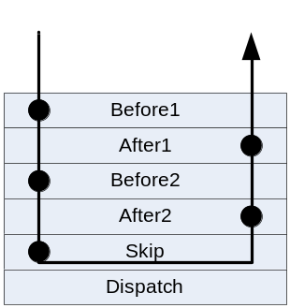

So all filters below a Skip filter won’t be executed, even Before and After filters, as shown in the following picture:
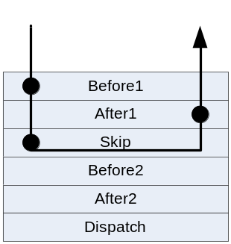

Building the inlining structure
The first task in inlining is transforming the filterset specification into an abstract procedural language structure, so that it can be mapped to a chosen procedural language. This inlining structure should maintain an abstract view of the actions and should only build the flowstructure between those actions.
To transform the filterset specification to the inlining structure, FIRE is used, because FIRE generates a model that represents how a filterset behaves when a certain message enters.
Two different solutions, with certain variants, have been identified to transform the FIRE model to an inlining structure. The first solution is based on the natural flow through the filterset. The second solution finds out for each possible action which complete condition expression as a combination of the different condition expressions in the filterset needs to be true for the action to be executed.

Flow Based Inlining
The Flow Based Inlining solution tries to build a flowstructure that corresponds with the natural flow through the filterset. It therefore divides the ExecutionModel into blocks of related states.

Dividing the ExecutionModel into blocks of related states

Filter blocks
The highest level blocks that are identified are the filter blocks. All states within such a filter block correspond with one filter. The following picture shows the flow structure between those filter blocks.

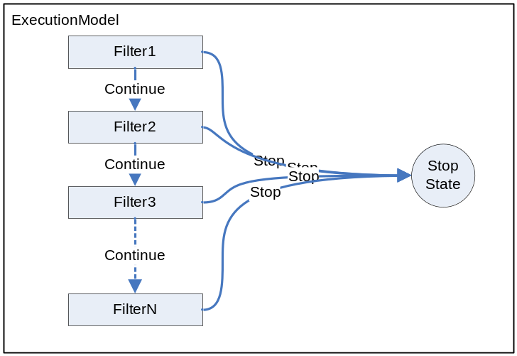

Flow from one filter block can continue to the next filter or can stop and exit the filterset. Note that this is an inclusive or. Both exits can be available from a filter block, but also only one might exist.

This structure is transformed to code by just putting the code for each filter block in sequence:
//code Filter1

//code Filter2

//code Filter3
.
.
.
//code FilterN

In this way flow goes naturally through the filterset when a ‘continue’ occurs. To enforce the ‘stop’ behaviour, the part of the algorithm that generates the code for the filter block has the requirement that it takes care of exiting this complete code-block when a stop occurs.

Filterelement blocks
Within a filter block a second level of blocks can be identified, the filterelement blocks. All states within such a block correspond with one filterelement. The following picture shows the flow structure between those filterelement blocks.

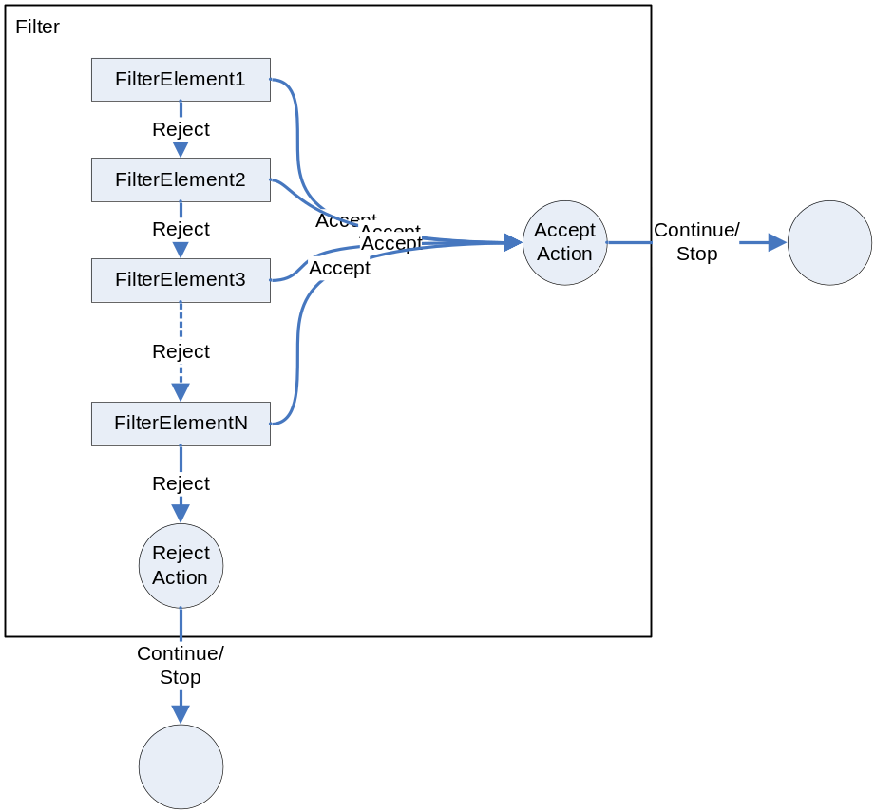

A filterelement can either accept or reject. On reject flow continues to the next filterelement. When the last filterelement rejects flow continues to the reject action. When a filterelement accepts, flow continues to the accept action. It should be noted that also in this case only one behaviour might be available; some Filterelements only accept while others only reject.
The flow behaviour from both action nodes (either continue or stop) depends on the type of the action.

Within the filterelement block no more blocks are identified. The following picture shows the flow between states inside the filterelement block.
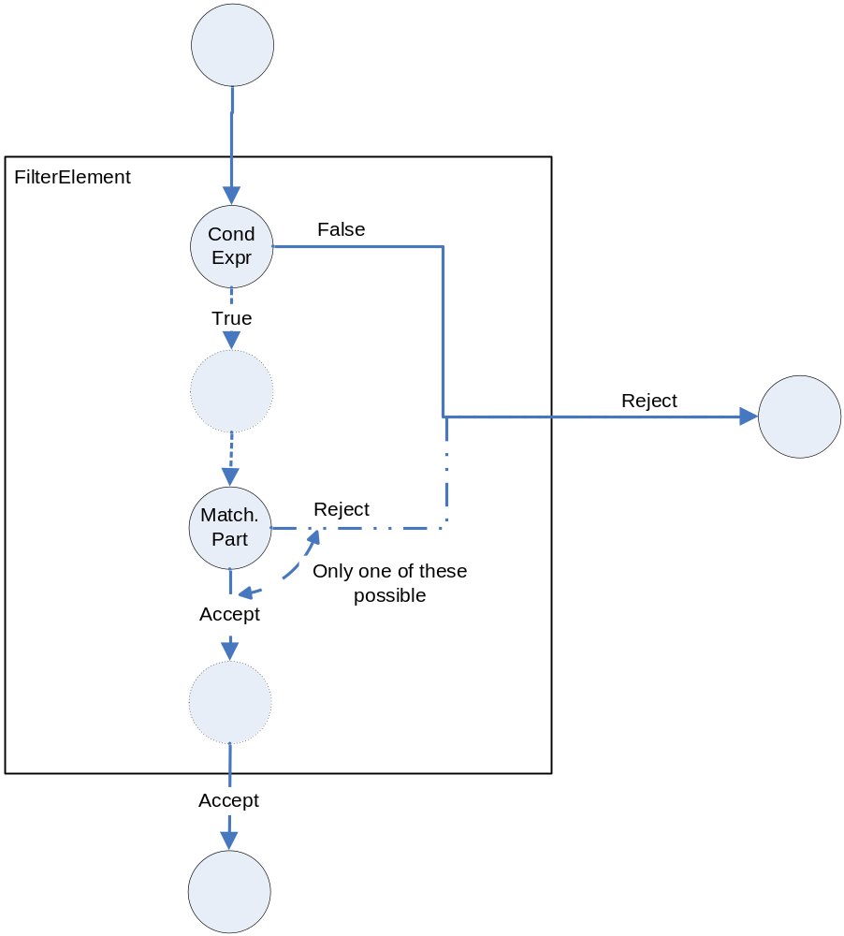

The first state in the filterelement block is the ConditionExpression state. This is also the only branching state. When the condition expression is false, the filterelement immediately rejects. When the condition expression is true, flow continues sequentially through a number of (in this description less important) states, until the MatchingPart state is reached. The matchingpart has one outgoing transition, which is either an accept transition or a reject transition. It has no branching, because the entrance message and all signatures where already known, so the behaviour of the matchingpart was already determined (by FIRE). When the matchingpart reject, the filterelement immediately rejects. When the matchingpart accepts, flow goes through some additional states and eventually leaves the filterelement as an accept.

The code generated for a filterelement and for the flow between the filterelements depends on the accept and reject behaviour of the filterelement. The following code example shows the generated code for a filterelement that can both accept and reject:

//FilterElement:
If (ConditionExpression){
//code for Accept action
}
Else{
//code for next FilterElement or Reject action
}

When the condition expression is true, the filterelement accepts, and so the accept action will occur.
When the condition expression is false, the filterelement rejects. Flow will either continue to the next filterelement or the reject action will occur. So the code for the next filterelement or for the reject action needs to be inlined in the ‘else’ block of the filterelement.
Not every filterelement will both accept and reject. When a filterelement always accepts, only the code for the Accept action is generated:

//FilterElement:
//code for Accept action

Because this filterelement always accepts, flow will never continue to a next filterelement, so no next filterelement needs to be inlined (there might be one that will be reached if we start with another message).
When a filterelement always rejects, this filterelement is skipped when there is a next filterelement (i.e. no code is generated) or the code for the reject action is generated, when there is no next filterElement:

//FilterElement:
//code for next FilterElement or Reject action

Problems
The problem with this solution is that it cannot cope with substitution. With substitution it is possible that the filterflow is not a linear structure. There can be different parallel filter blocks for the same filter, as shown in the following picture (the stop-state is omitted for clarity).

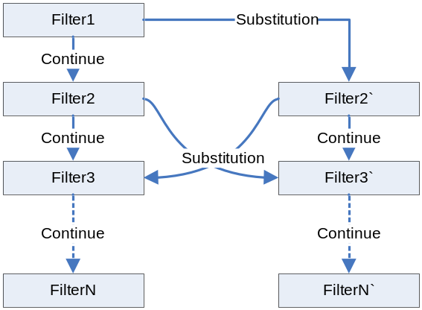

This flow structure can’t be implemented by just placing the filters in sequence. The following section provides a completely different solution that does not have this problem. In the sections thereafter variants of the flow-based solution are introduces that solve this problem.

Condition Based Inlining
The second solution does not use the natural flow through the filterset to decide which actions are executed, but the combination of all condition expressions that lead to a certain action. Because the flow only branches at condition expressions, we can calculate for each state in the ExecutionModel the combined condition expression that leads to this state. The next part will explain the algorithm to calculate those combined condition expressions. Thereafter it will be explained how code is generated from this.

Algorithm
The algorithm is based on four different rules.

Rule1 Start rule

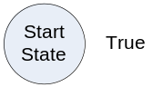

This rule applies to the start state and initializes this state with the condition expression True. (i.e. flow will always reach this state).

Rule2 Pass-on rule

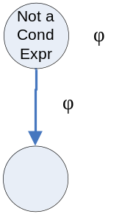

When a state is not a ConditionExpression state, than this state just inflicts it’s own conditionexpression to the next states.

Rule3 ConditionExpression rule

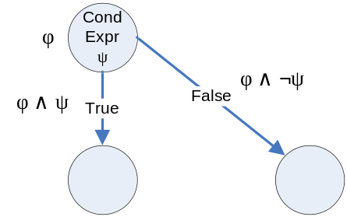

When a state is a ConditionExpression state with the condition expression ψ and annotated with condition expression φ, than this state inflicts the condition expression φ∧ψ on its true-next state and φ∧¬ψ to the false-next state. This can be explained as follows: if we want to do the true-transition, then we first have to reach the start-state. To reach the start-state the conditionexpression φ needs to be true. Then to do the true-transition from the start-state, also the conditionexpression ψ needs to be true. So to do the transition, both the conditionexpressions φ and ψ need to be true, so φ∧ψ needs to be true. This reasoning is the same for the false-transition, with the difference that ψ needs to be false to do the transition.

Rule4 Combination rule

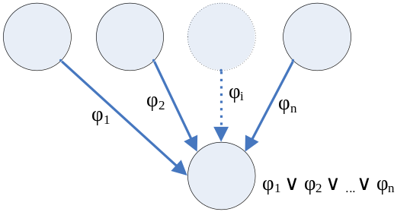

This rule combines all inflicted condition expressions on a state to the condition expression that is annotated to the state. All inflicted condition expressions through all incoming edges are combined with an or-operator. This can be explained as follows: to reach the state, you have to reach the state through one of the incoming transitions. So at least one of the inflicted condition expressions needs to be true to reach the state.

Generating code
[TODO]

Problems
One problem about this solution is that the conditions used in the condition expressions cannot change during the evaluation of the filterset, because the control flow in the implementation does not correspond anymore with the message flow through the filterset.

Flow Based Inlining with jump instructions
In the original flow based solution the flow between the filters was implemented as a flat sequential structure where each filter’s code followed the previous filter’s code. This became a problem with substitution, because then the flow between filters was not sequential anymore. One solution for this problem is to use jump instructions to jump between the code for the different filters, when necessary. If we take the example again:

We see that the flow between the filters is not sequential. We get different parallel filter flows, with substitution actions between the different flows. We can implement this by just implementing each parallel flow as a sequence and jumping to a filter in another flow when a substitution occurs. If we implement the example in pseudocode, we get the following:

Filter1:
…
//SubstitutionAction:
Jump Filter2’;
…

Filter2:
…
//SubstitutionAction:
Jump Filter3’;
…

Filter3:
//code Filter3

.
.
.

FilterN:
//code FilterN
//jump to the end of the filterset:
Jump End;

Filter2’:
…
//SubstitutionAction:
Jump Filter3;
…

Filter3’:
//code Filter3’

.
.
.

FilterN’:
//code FilterN’

End:
//end of filterset

Flow Based Inlining with message conditions
In the previous section a solution was presented to cope with substitution. This solution however used jump instruction, a language construct that may not be available in every language. This section presents a variant of the flow-based solution that can cope with substitution but uses only high-level language constructs.
Substitution leads to different possible messages in the filterset. This leads to different parallel flowtraces through the filterset, with substitution as the flow-connection between the flowtraces, as seen in the following picture:

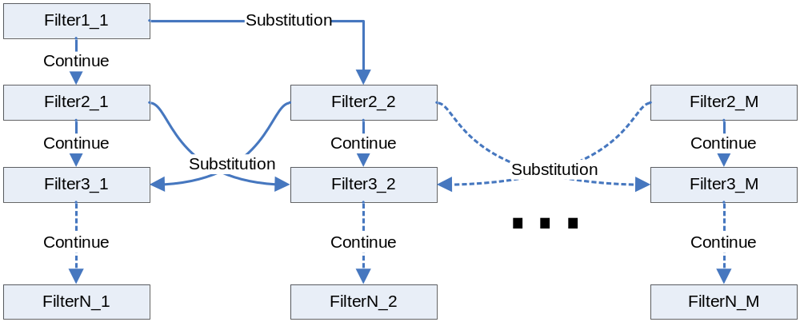

Each possible message in the filterset execution has its own flowtrace (keep in mind that we start with one single message and the other possible messages are only obtained through substitution). The Substitution actions provide the flow-bridge between the different flowtraces.
The solution to the substitution problem is based on giving every flowtrace a unique number, in this way giving every possible message a unique number. This is done in the example, where the flowtraces are numbered 1 to M. In every part of the execution we know the current message, so we know the number of the message. We can store this number in a variable. This can now be used before a certain filter block is executed, to determine whether it corresponds with the right message, as shown in the following code example:

Filter3_2:
If ( number == 2 ){
//filtercode
}

To make sure the filters are executed in the correct order, the code has to be generated layer by layer, as seen in the following picture and code example:

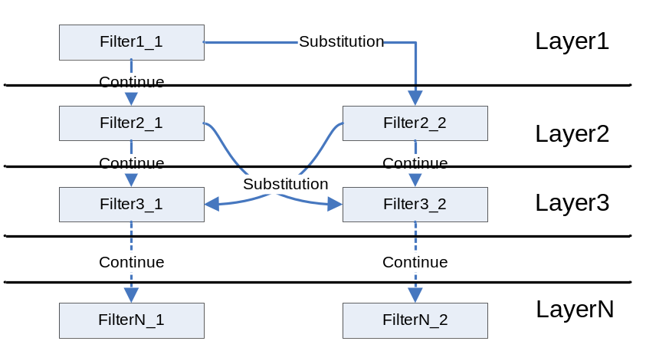

Int number = 1;

//Layer1
Filter1_1:
If ( number == 1 ){
…
number = 2; //SubstitutionAction
…
}

//Layer2
Filter2_1:
If ( number == 1 ){
…
number = 2; //SubstitutionAction
…
}

Filter2_2:
If ( number == 2 ){
…
number = 1; //SubstitutionAction
…
}

//Layer3
Filter3_1:
If ( number == 1 ){
…
}

Filter3_2:
If ( number == 2 ){
…
}

.
.
.

//LayerN
FilterN_1:
If ( number == 1 ){
…
}

FilterN_2:
If ( number == 2 ){
…
}

In this way the right filters are executed in the right order.

Note that we could have also used the message itself instead of a number to do the comparison. But generally the comparison of two integers is much faster than the comparison of two messages, which consists of a target and a String selector. So for efficiency reasons integer comparison is better.

The drawback of this solutions in comparison with the solution based on jump instructions is that we have to do checks before we can execute the right code, which can be many if there are many possible messages. With the jump instructions we immediately jumped to the right filter block.

Abstract Instruction Model
The inlining structure is stored in an Abstract Instruction Model. The following picture shows the class diagram of this model:

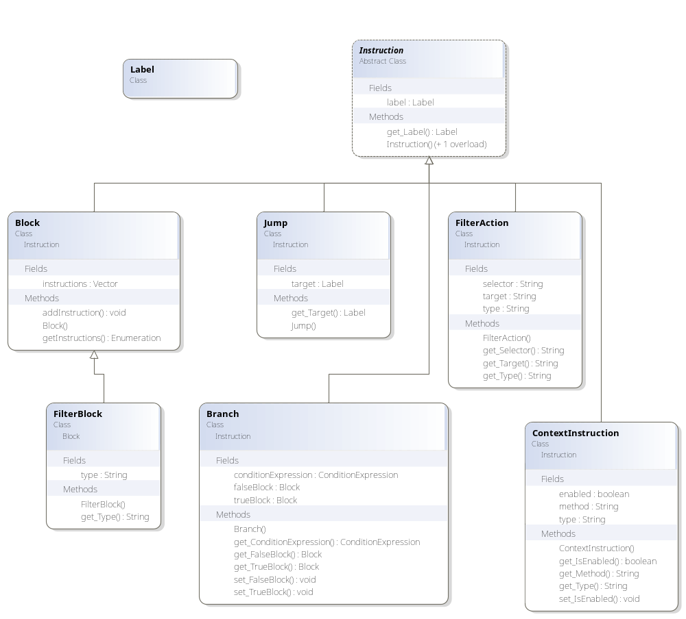

Instruction is the abstract base class. It contains only an (optional) label.
Block is an Instruction that is a container for other instructions.

FilterBlock is a specific kind of block to indicate that it is the block for a filter. It contains also the type of the filter.

Jump is an Instruction to jump to a certain other instruction, which has the label specified in the jump instruction.

Branch is an Instruction that implements the branching. It contains a condition expression, a true block and a false block. Based on the truth value of the condition expression, a branch should be done to either the true block or the false block.

ContextInstruction is an Instruction to set something in the FilterContext. In the chapter about weaving is explained in detail why we need Filter Context. Currently the filter context is only used to indicate whether a call is an inner call or not. The inner call context should be set when an innercall is done and when the target method has input filters inlined. The inliner tool determines this and when this is the case it generates a special instruction to indicate this to the weaver.

FilterAction is an Instruction that represents that some filteraction needs to be executed.

Translating Filteractions to Code
Before the weaver can weave the filter code in the original code, it first has to translate the abstract instructions to code in the target language. Most parts of the abstract instruction structure can be directly mapped to the target language, for example the branch and jump instructions. The only abstract instructions that can’t be directly mapped into the target language structure are the Filteractions. This section explains for most filteractions how they can be translated to the target language code (for which pseudocode is used in this document).

ContinueAction
The ContinueAction is the simplest of all filteractions. No code needs to be generated for this action.

SubstitutionAction
When a SubstitutionAction occurs, a jump needs to be done, according to the Flow Based Inlining with Jump Instructions. This jump is already present in a separate instruction.

ErrorAction
An ErrorAction should be translated to something like an exception:

throw new Exception();

DispatchAction
A DispatchAction should be translated to a call with the arguments of the original call (which was intercepted by the filters):

dispatchMethod( <arguments> );

When the method returns a value, this value should be stored (for example in some field or directly on top of the stack), because it may be used by an after filter and it may be used by the original code after the filters ended there execution.

BeforeAction
A BeforeAction should be implemented as a call to a certain method that implements the advice. This advice might want to use information about the called method, the sender and target, and the value of the arguments. So before the call to the advice can be done, this information needs to be stored into a PointCutContext object, which is given as a parameter to the advice method. After the call, the advice might have changed the parameter values, so they have to replace to original values.
For the BeforeAction we get the following pseudocode:

//create context:
JoinPointContext context = new JoinPointContext();
context.setMethodInfo( MethodInfo );
context.setTarget( this );
context.addArgument( 1, arg1Type, arg1Value );
context.addArgument( 2, arg2Type, arg2Value );
context.addArgument( 3, arg3Type, arg3Value );

//call before advice:
beforeAdvice( context );

//put back arguments:
arg1Value = context.getArgument( 1 );
arg2Value = context.getArgument( 2 );
arg3Value = context.getArgument( 3 );

This is the code for an inputfilter. In an inputfilter we don’t know the sender of the call, without using reflection, so this information is not set in the PointCutContext. For an outputfilter we do set the sender:

context.setSender( this );
context.setTarget( targetObject );

AfterAction
Just as a BeforeAction the AfterAction should also be implemented as a call to the method that implements the advice. Also the PointCutContext object needs to be created. In addition to the information given to the PointCutContext in the BeforeAction, the AfterAction also gives the return-value to the PointCutContext. And after the execution of the advice, also the returnvalue needs to be placed back, because it may be changed.
For the AfterAction we get the following pseudocode:

//create context:
JoinPointContext context = new JoinPointContext();
context.setMethodInfo( MethodInfo );
context.setTarget( this );
context.addArgument( 1, arg1Type, arg1Value );
context.addArgument( 2, arg2Type, arg2Value );
context.addArgument( 3, arg3Type, arg3Value );
context.setReturnValue( returnValueType, returnValue );

//call before advice:
beforeAdvice( context );

//put back arguments and returnvalue:
arg1Value = context.getArgument( 1 );
arg2Value = context.getArgument( 2 );
arg3Value = context.getArgument( 3 );
returnValue = context.getReturnValue();

This is again the code for the inputfilters. For the outputfilters the sender information is added to the context in the same way as in the BeforeAction.

SkipAction
When a SkipAction occurs, a jump should be done to the last AfterFilter. But this jump is already present in the Abstract Instruction block as a separate instruction, so no code needs to be generated for the SkipAction.

Weaving

Weaving input filters
Input filters work on the called object, so they should be weaved in that class. The inputfilters are executed before the called method is executed, so the filtercode for each method should be placed in such a way that it is executed before the original code. It should also work in such a way that when an inner-call to the method occurs, the filtercode isn’t executed. Two possible solutions are discussed. The first solution uses method wrapping. The second solution places the filtercode directly at the beginning of the methodbody, followed by the original code.

Method Wrapping
The following picture shows how method wrapping works.

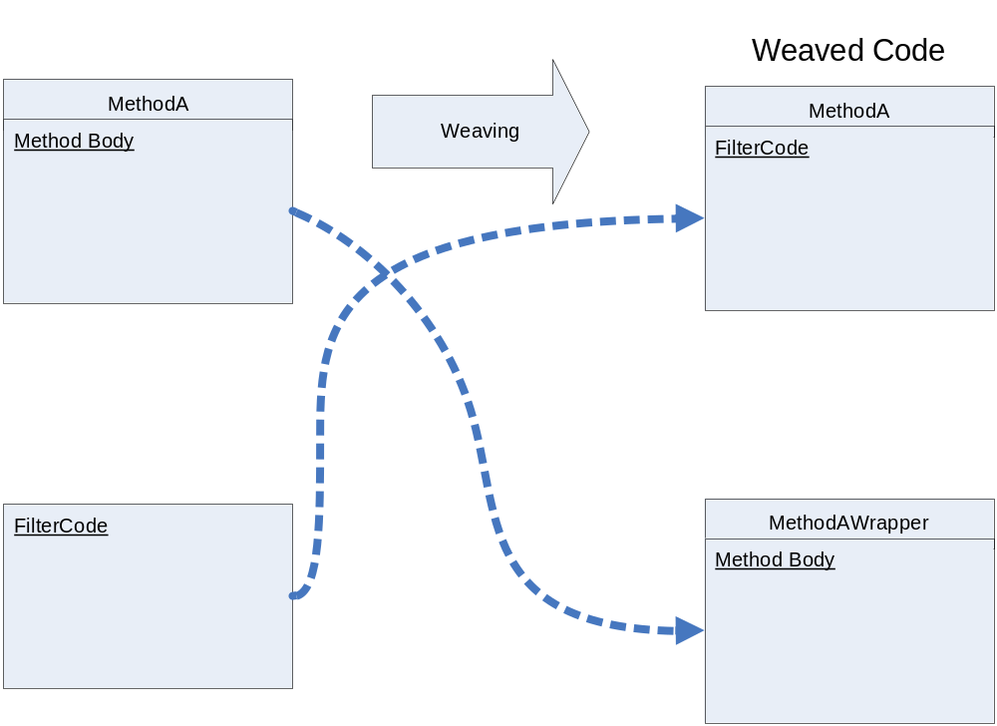

With method wrapping the original code is placed inside a wrapper method. The filtercode is placed in the body of the original method.
In this way, when the method is called, the filtercode is executed first. When an inner-call occurs to the method (either from the methods own filtercode, or from another methods filtercode), this call should be targeted to the wrapper method and not to the original method. In this way the filtercode is not executed on an inner-call.

Problems
Method wrapping has one serious drawback. When the original method is overridden in a subclass which has no filterset superimposed and the method is called with an inner-call from another methods filtercode (in the class itself), then this call is targeted at the wrapper-method, so the original code is executed and not the overriding code in the subclass.

Filtercode Insertion
Another solution is to insert the filtercode directly at the beginning of the method body, followed by the original code, as shown in the following picture.

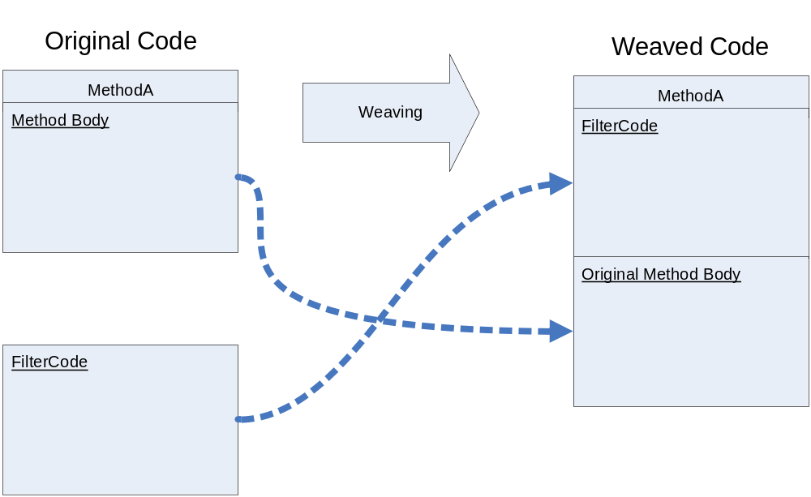

This solution solves the problem method wrapping has with overriding, but it introduces the problem of how to do inner calls. We cannot just change the target method when an inner call occurs, but we have to find a solution to skip the filtercode at the beginning of the method body when an inner call is done.

Introducing FilterContext
To solve the problem of the inner calls a FilterContext is introduced. The FilterContext can be queried to check whether the call is an innercall. The following example shows this in pseudocode:

If (!FilterContext.isInnerCall()){
//filtercode
}
FilterContext.resetInnerCall();

On the calling side (which is always inside filtercode in the same class), the FilterContext should be set when an inner-call needs to be done and when the called method has filters inlined:

FilterContext.setInnerCall();
this.<calledMethod>(..); //the call

When the called method does not have filters inlined, the innercall should not be set in the filtercontext, because it might lead to problems when the called method calls (indirectly) another method which has filters inlined. These filters should be executed, but are not executed, because the FilterContext has the innercall set.

At first hand this solution seems to work fine, but it has a problem. When the inlined method is being overridden in a subclass and this overriding method has no inlined filters and does not call the supermethod, the innercall context is not reset on an inner call (because the overriding method is being executed). This again leads to problems when the overriding method calls another method which has filters inlined, as shown in the following picture.

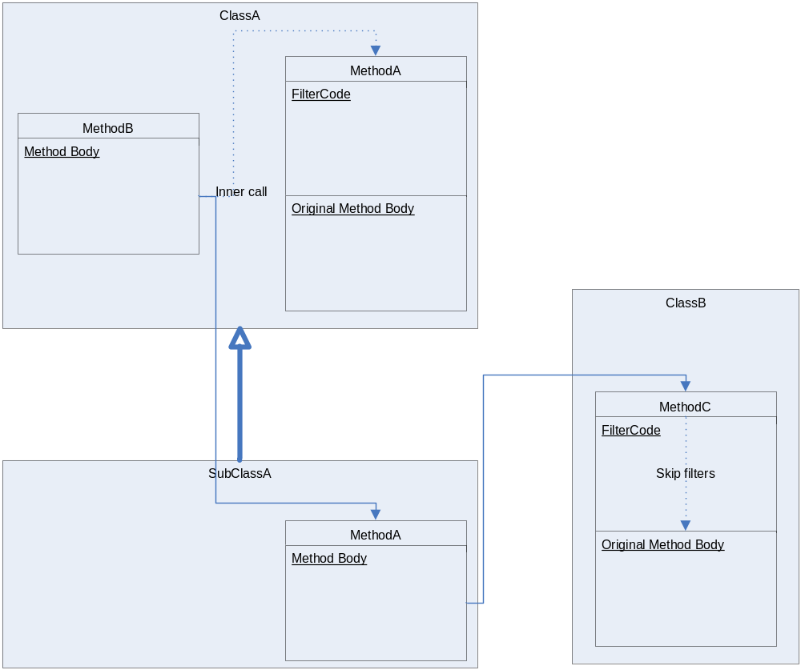
One solution to solve this problem is to do a reset of the innercall context at the start of every method which has no filters inlined. This however is not always possible, for example when we use an inlined assembly in a project which doesn’t use Compose* but just the base language. It also might give unwanted behaviour on a supercall (the filters are then executed).
Another solution is to add information about the methods signature and the target object for which the innercall context is set. When the innercall context is checked, this information is used to determine whether it is the right method. The following example shows the changed pseudocode:

If (!FilterContext.isInnerCall( this, methodInfo )){
//filtercode
}
FilterContext.resetInnerCall();

FilterContext.setInnerCall( this, calledMethodInfo);
this.<calledMethod>(..); //the call

The only problem that is left is when we override the method in a subclass and we do an (indirect) call to the same method in the superclass in the same object (not with a super-call), then the filters are not executed, although they should be.

As a final remark it should be noticed that the innercall context should be thread-dependent, to avoid concurrency problems. With thread-dependent is meant that every thread has its own innercall context. So if we have for example the following sequence of actions:

Thread1: FilterContext.setInnerCall( this, methodInfo );
Thread2: FilterContext.isInnerCall( this, methodInfo );
Thread2: FilterContext.resetInnerCall();
Thread1: FilterContext.isInnerCall( this, methodInfo );

The truth-values should not be like this:

Thread1: FilterContext.setInnerCall( this, methodInfo );
Thread2: FilterContext.isInnerCall( this, methodInfo ); => true
Thread2: FilterContext.resetInnerCall();
Thread1: FilterContext.isInnerCall( this, methodInfo ); => false

But like this:

Thread1: FilterContext.setInnerCall( this, methodInfo );
Thread2: FilterContext.isInnerCall( this, methodInfo ); => false
Thread2: FilterContext.resetInnerCall();
Thread1: FilterContext.isInnerCall( this, methodInfo ); => true

On most platforms, like Java or .Net, this is straightforward to implement in the FilterContext class by internally maintaining an internal context object for each thread that uses it.

Weaving Output Filters
Outputfilters work on the calling object, so they should be inlined in that class. The outputfilters are executed when a call occurs, so the best place to weave them is at the place where the call occurs. The filtercode then replaces to original call. This is shown in the following picture.

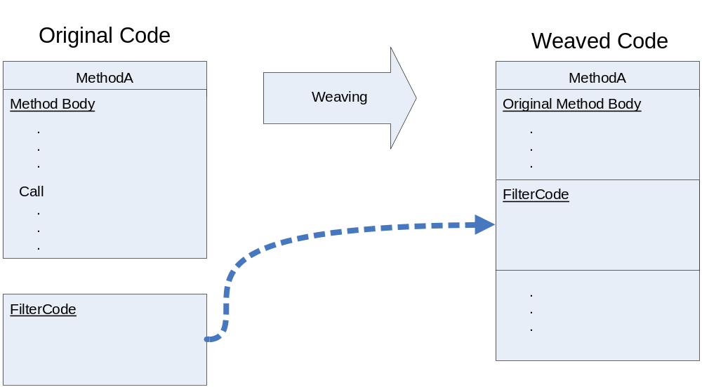

With outputfilters we don’t have to check the innercall context. We only need to set it when we do an inner call.

